Use DocFX to auto document comments

# 1. What is *DocFX*

* *DocFX* is an API documentation generator for .NET, which currently supports C#, VB and F#.
* It generates API reference documentation from triple-slash comments in your source code.
* It also allows you to use Markdown (*.md) files to create additional topics such as tutorials and how-tos, and to customize the generated reference documentation.
* *DocFX* builds a static HTML website from your source code and Markdown files, which can be easily hosted on any web server (for example, *github.io*).
* These HTML files are dynamically loaded and need a web server. So don’t open it on the file folder
* Also, *DocFX* provides you the flexibility to customize the layout and style of your website through templates. If you are interested in creating your own website with your own styles, you can follow [how to create custom template](https://dotnet.github.io/docfx/tutorial/howto_create_custom_template.html) to create custom templates.

# 2. Use *DocFx* integrated with Visual Studio

* Google “nuget docfx” and install it against the project you want to document

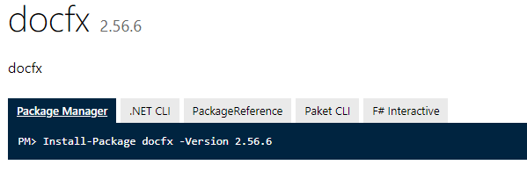

* Use triple “///” to comment the code
* Right click the project on Solution Explorer 🡪 Properties 🡪 Build tab 🡪 check XML documentation file:

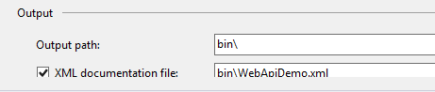

* Build project or solution, a _site folder will be generated with the documentation
* To host it, open Package Management Console and run

docfx WebapiDemo/docfx.json

if there is no error, then the site for the documentation will be served:

